Java Basics:

# String:

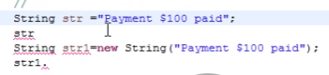

# String functions:

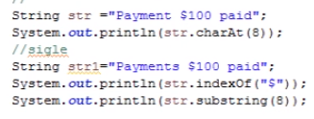

# Reversing the String and Check for Palindrome:

